Name
Class
Date

9-1
Translations
Practice
Form G

Tell whether the transformation appears to be an isometry. Explain.

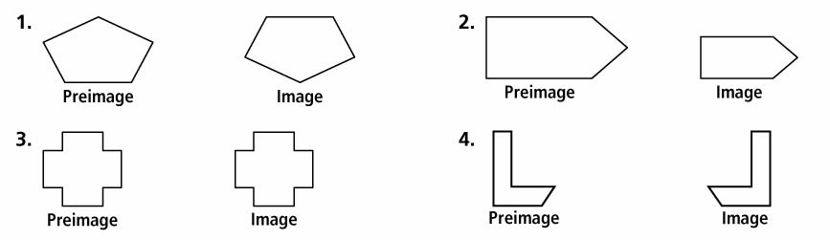
1. 2.

3. 4.

In each diagram, the dashed-line figure is an image of the solid-line figure.
- Choose an angle or point from the preimage and name its image.
- List all pairs of corresponding sides.
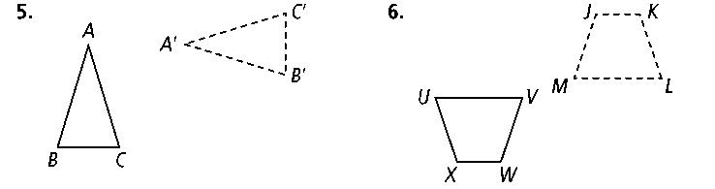
5. 6.

Graph the image of each figure under the given translation.

7. 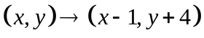 8. 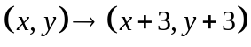

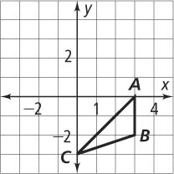
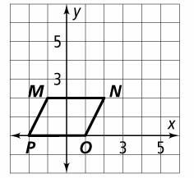

The dashed-line figure is a translation image of the solid-line figure. Write a rule to describe each translation.

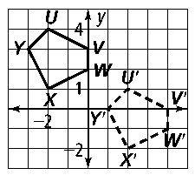
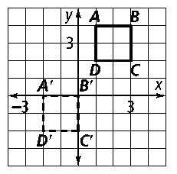
9. 10.

Prentice Hall Gold Geometry • Teaching Resources
Copyright © by Pearson Education, Inc., or its affiliates. All Rights Reserved.
3

Name
Class
Date

9-1
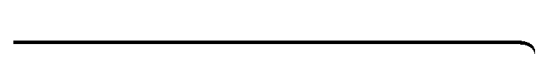
Practice (continued)
Form G
Translations

11. You are visiting Washington, D.C. From the American History Museum you walk 5 blocks east and 1 block south to the Air and Space Museum. Then you walk 8 blocks west to the Washington Monument. Where is the Washington Monument in relation to the American History Museum?
12. You and some friends go to a book fair where booths are set out in rows. You buy drinks at the refreshment stand and then walk 8 rows north and 2 rows east to the science fiction booth. Then you walk 1 row south and 2 rows west to the children’s book booth. Where is the children’s book booth in relation to the refreshment stand?
13. Reasoning The translation (x, y) → (x + 10, y + 15) maps PQRS onto P′Q′ R′ S′. What translation maps P′Q′R′S′ onto PQRS?
14. ΔXYZ has coordinates X(2, 3), Y(1, 4), and Z(8, 9). A translation maps X to X′ (4, 7). What are the coordinates for Y′ and Z′ for this translation?

15. Use the graph at the right. Write three different translation rules for which the image of ΔRST has a vertex at the origin.
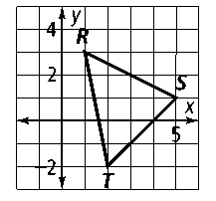

16. Use the graph at the right. Write three different translation rules for which the image of ΔBCD has a vertex at the origin.
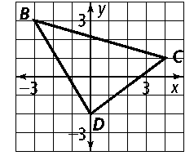

Graph the image of each figure under the given translation.

17. 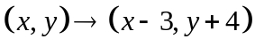 18. 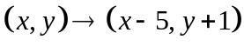

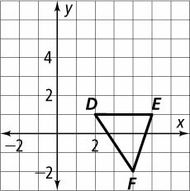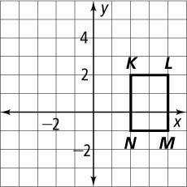
Prentice Hall Gold Geometry • Teaching Resources
Copyright © by Pearson Education, Inc., or its affiliates. All Rights Reserved.
4

