Name___________________
Date________________
Geometry Period _____
Chapter 10: Area Project

- A garden is in the shape of a semicircle with a diameter of 40m. What is the area of the garden? Make sure to draw and label the shape. (1 Point)

- A craft project requires the covering of just a portion of a round lid with a strip of material. The diagram below shows a darkened arc that would represent the strip. The diagram shows a circle with center O and radius 42 inches. A and B are points on the circumference such that arc AB makes an angle of 120°. Calculate the length of the required strip of cloth. (1 Point)
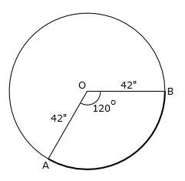

- A gardener needs enough potting soil to cover a certain section of ground. The darkened sector of the diagram below shows the area that the gardener needs to cover. The diagram shows a circle with center O and radius 42 feet. A and B are points on the circumference such that arc AB makes an angle of 120° at O. Calculate the area that needs to be covered with potting soil. (1 Point)
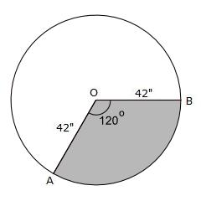
42 ft

- The children’s’ merry-go-round needs a new coat of paint. The darkened segment below represents the portion that will be painted yellow. The diagram shows a circle with center O and radius 10 ft. A and B are points on the circumference such that arc AB makes an angle of 150° at O. Calculate the area that will need to be painted white. (1 Point)
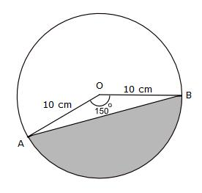
10 ft

- A piece of metal stripping will be used to outline a craftsman’s workbench. The workbench has a shape made of a square and a semicircle. Find the perimeter of the shape so that we can find out how much metal stripping is needed? (1 Point)
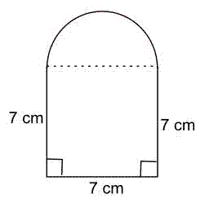
7 m
7 m
7 m

- A carpenter is creating the design below as an ornament. The shape is made up of four quarter-circular arcs, each of radius 5 inches, joined together. Label the figure below. The shape will need to be covered with fabric. Find the area of the shape so that we can find out how much fabric is needed? (1 Point)
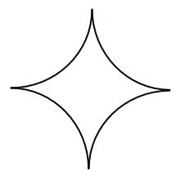
- A metal tool consists of a semicircle and a triangle joined together. What area of metal is needed to make the tool? (1 Point)
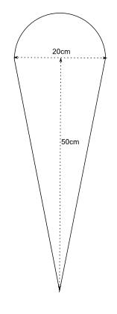
- Crown molding need to be installed in a uniquely shaped room. The shape below represents the ceiling of the room. It is a square with two quarter circles cut from opposite corners. Label some of the missing measurements. Find the perimeter of the shape so that you can determine how much of the crown molding you would need. (1 Point)
16 ft
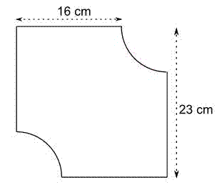
23 ft

