Chapter 12 Checklist: Circles Your Name:____________

You MUST complete all of these packet items in order to take your test!

_______12-1 Notes (1 Point)
_______ Standardized Test Prep 12-1
_______ 12-1 Quiz (4 Points)

_______12-2 Notes (1 Point)
_______ Standardized Test Prep 12-2
_______ 12-2 Quiz (3 Points)

_______12-5 Notes (1 Point)
_______ Standardized Test Prep 12-5
_______ 12-5 Quiz (3 Points)

_______12-3 Notes (1 Point)
_______ Standardized Test Prep 12-3
_______ 12-3 Quiz (5 Points)

_______12-4 Notes (1 Point)
_______ Standardized Test Prep 12-4
_______ 12-4 Quiz (5 Points)

Vertex On
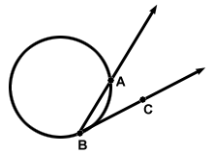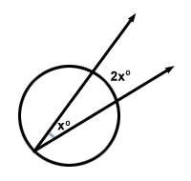

_______12-4 Crossword Puzzle
_______ Tangents to Circles Worksheet
_______ Equations of Circles Worksheet
_______ Inscribed Angles Worksheet
_______ Secant Angles Worksheet
_______ Chapter 12 Project (3 Points)
_______ Chapter 12 Vocabulary Test (10 Points)
_______ Chapter 12 Test (25 Points)

Vertex Outside
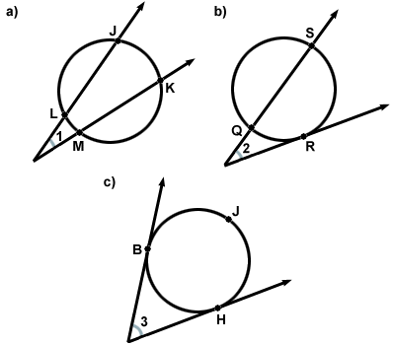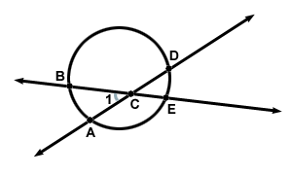
Vertex Inside

