Chapter 3 Checklist: Parallel and Perpendicular Lines Your Name:____________

_______Constructions Practice Ch 3
_______ 3-6 Constructions Quiz (2 Points)

_______3-1 Notes (1 Point)
_______ Standardized Test Prep 3-1
_______ 3-1 Quiz (5 Points)

_______3-2 Notes (1 Point)
_______ Standardized Test Prep 3-2
_______ 3-2 Quiz (3 Points)

_______3-3 Notes (1 Point)
_______ Standardized Test Prep 3-3
_______ 3-3 Quiz (2 Points)
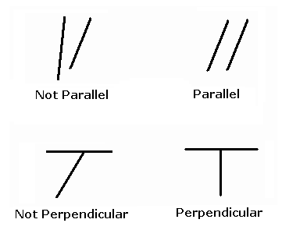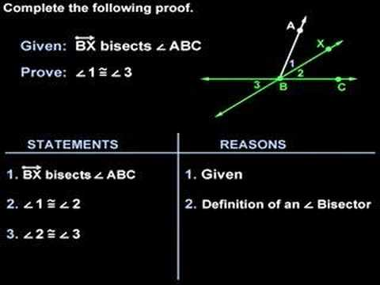
_______3-4 Notes (1 Point)
_______ Standardized Test Prep 3-4
_______ 3-4 Quiz (2 Points)

_______3-5 Notes (1 Point)
_______ Standardized Test Prep 3-5
_______ 3-5 Quiz (4 Points)

_______3-7 Notes (1 Point)
_______ Standardized Test Prep 3-7
_______ 3-7 Quiz (5 Points)

_______3-8 Notes (1 Point)
_______ Standardized Test Prep 3-8
_______ 3-8 Quiz (4 Points)

_______Angles In a Triangle Page
_______ 3-1 Games and Puzzles Activity
_______ 3-3 Games and Puzzles Activity
_______ 3-5 Games and Puzzles Activity (Only Activity 1 and Activity
2 Need to be completed.)

_______ 3-6 Games and Puzzles (Construction Activity – Must
Complete Steps 1-3)

_______ Chapter 3 Project – Geometer’s Sketchpad Activity (10
Points)

_______ Chapter 3 Vocabulary Test (10 Points)
_______ Chapter 3 Test (25 Points)

