Chapter 6 Checklist: Polygons and Quadrilaterals Your Name:____________

_______5-1 Notes (1 Point)
_______ Standardized Test Prep 5-1
_______ 5-1 Quiz (3 Points)

_______6-1 Notes (1 Point)
_______ Standardized Test Prep 6-1
_______ 6-1 Quiz (4 Points)

_______6-2 Notes (1 Point)
_______ Standardized Test Prep 6-2
_______ 6-2 Quiz (4 Points)

_______6-3 Notes (1 Point)
_______ Standardized Test Prep 6-3
_______ 6-3 Quiz (3 Points)

_______6-4 Notes (1 Point)
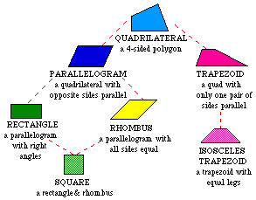
_______ Standardized Test Prep 6-4
_______ 6-4 Quiz (3 Points)

_______6-5 Notes (1 Point)
_______ Standardized Test Prep 6-5
_______ 6-5 Quiz (2 Points)

_______6-6 Notes (1 Point)
_______ Standardized Test Prep 6-6
_______ 6-6 Quiz (5 Points)

_______6-7 Notes (1 Point)
_______ Standardized Test Prep 6-7
_______ 6-7 Quiz (2 Points)

_______ 6-1 Game
_______Polygons and Angles
_______Angles in Quadrilaterals
_______Properties of Parallelograms
_______Classifying Quadrilaterals
_______ 6-5 Puzzle
_______Geometer’s Sketchpad Activity (13 Points)

_______ Chapter 6 Project (18 Points)

_______ Chapter 6 Vocabulary Test (10 Points)
_______ Chapter 6 Test (26 Points)

