Chapter 2 Checklist: Reasoning and Proof Your Name:__________________
You must complete ALL of the items below before you can take the chapter test!

_______2-2 Notes (1 Point)
_______ Standardized Test Prep 2-2
_______ 2-2 Quiz (4 Points)

_______2-3 Notes (1 Point)
_______ Standardized Test Prep 2-3
_______ 2-3 Quiz (3 Points)
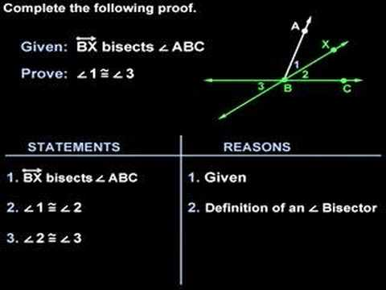
_______2-4 Notes (1 Point)
_______ Standardized Test Prep 2-4
_______ 2-4 Quiz (3 Points)

_______2-5 Notes (1 Point)
_______ Standardized Test Prep 2-5
_______ 2-5 Quiz (5 Points)

_______2-6 Notes (1 Point)
_______ Standardized Test Prep 2-6
_______ 2-6 Quiz (3 Points)

_______ Proof Sheet
_______ Geometer’s Sketchpad Angle Activity
_______ Angle Pair Relationships Sheet

_______ 2-4 Games and Puzzles Activity
_______ 2-6 Games and Puzzles Activity
_______ Chapter 2 Performance Task(16 Points)
_______ Chapter 2 Vocabulary Test (10 Points)
_______ Chapter 2 Test (20 Points)

