Chapter 1 Checklist: Tools of Geometry Your Name:______________
You must complete ALL of the items below before you can take the chapter test!

_______1-2 Notes (1 Point)
_______ Standardized Test Prep 1-2
_______ 1-2 Quiz (6 Points)

_______1-3 Notes (1 Point)
_______ Standardized Test Prep 1-3
_______ 1-3 Quiz (5 Points)
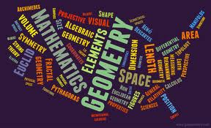

_______1-4 Notes (1 Point)
_______ Standardized Test Prep 1-4
_______ 1-4 Quiz (5 Points)

_______1-5 Notes (1 Point)
_______ Standardized Test Prep 1-5
_______ 1-5 Quiz (7 Points)

_______1-7 Notes (1 Point)
_______ Standardized Test Prep 1-7
_______ 1-7 Quiz (4 Points)

_______ Construction Sheet
_______ Geometer’s Sketchpad Activity

_______ 1-3 Games and Puzzles Activity
_______ 1-4 Games and Puzzles Activity
_______ 1-5 Games and Puzzles Activity
_______ Chapter Project (15 Points)
_______ Chapter 1 Vocabulary Test (10 Points)
_______ Chapter 1 Test (30 Points (3 Constructions and 27 Multiple Choice)

