Chapter 9 Checklist: Transformations Your Name:____________

_______9-1 Notes (1 Point)
_______ Standardized Test Prep 9-1
_______ 9-1 Quiz (4 Points)

_______9-3 Notes (1 Point)
_______ Standardized Test Prep 9-3
_______ 9-3 Quiz (3 Points)

_______9-2 Notes (1 Point)
_______ Standardized Test Prep 9-2
_______ 9-2 Quiz (3 Points)

_______9-6 Notes (1 Point)
_______ Standardized Test Prep 9-6
_______ 9-6 Quiz (2 Points)

_______9-5 Notes (1 Point)
_______ Standardized Test Prep 9-5
_______ 9-5 Quiz (4 Points)

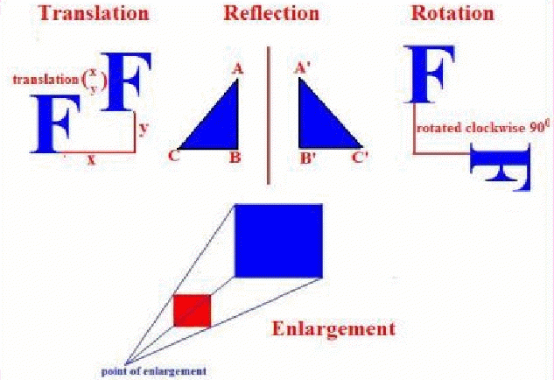

Dilation

_______Translations Worksheet
_______Reflections Worksheet
_______Rotations Worksheet
_______Geometer’s Sketchpad Activity (8 Points)

_______ Chapter 9 Project (18 Points)

_______ Chapter 9 Vocabulary Test (10 Points)
_______ Chapter 9 Test (20 Points)

